

Since the 1970s 41% of all UK species have declined

***HARINGEY BIODIVERSITY NEWSLETTER No 1 July 2021***

This newsletter is being produced as a trial run by Haringey Climate Forum, and as a follow-up to the successful meeting held online on 17th May about Haringey’s Biodiversity Action Plan. Its aims are:

* provide a forum for discussion of biodiversity in Haringey and to highlight successful projects
* exchange news and views and information on new biodiversity projects by Haringey and other organisations
* discuss the content of the Biodiversity Action Plan and its progress through the council structure, as well as associated Local Plan elements such as the Trees and Woodland Plan
* give information on relevant ideas and projects in other London boroughs, particularly local ones

Please let us know what you think of this experiment and the content, missing or unexplored subjects.It would be great if you can write a short article or suggest people who might write a short piece. Contact us on: [info@haringeyclimateforum.org](mailto:info@haringeyclimateforum.org)

**BIODIVERSITY ACTION PLAN**

It looks as though the Biodiversity Action Plan will be issued in September for consultation, closing in early autumn. As soon as we get a link to the documents we will circulate this.

**Parks and Green Space Strategy**

The Borough Plan has a commitment to develop a new Parks and Green Space Strategy (PGSS) for the Borough. The BAP has been developed as one section of the overarching PGSS, to be supported by the following plans:

* Biodiversity action plan
* Trees and woodlands plan
* Asset management plan
* Watercourse and flood management plan
* Volunteer and community engagement plan
* Parks workforce development plan
* A funding plan
* An action plan  
  These will form a key part of the evidence base for the new Local Plan, and the BAP and trees and woodland plans are very important elements.

**Sites of Importance for Nature Conservation (SINCs)**

The council has contracted MKA Ecology to review the SINCs in Haringey. This will feed into the BAP. If you have biological records about a SINC – or a site you think should be a SINC – please send it to Annabel Foskett [annable.foskett@haringey.gov.uk](mailto:annable.foskett@haringey.gov.uk)

**TOTTENHAM MARSHES – HARINGEY’S BIODIVERSITY JEWEL**

Haringey shares in what is arguably the biodiversity jewel in London’s crown – the Lea Valley. Since the last boundary changes we no longer include any of the reservoirs but Tottenham marshes and The Paddock are part of the wider Lea ecosystem and add to its richness – which includes kingfishers, little egrets (and this year a Great White Egret), grebes, terns, weasels and newts.

But while this area attracts thousands (especially during lockdown) to enjoy its green space and wildlife, the reality is less gleaming. The building of the A1055 in the 1990s wiped out 10% of the marshes and brought noise and traffic danger to its edge. The river water is depleted by over-abstraction from chalk higher up the Lea valley and marred by frequent sewage discharges. Meanwhile moth populations have plummeted, due to climate change and maybe pesticide use elsewhere, and this makes it harder so sustain bats, flycatchers and other insectivores.

So Haringey’s Biodiversity Action Plan needs to rigorously tackle local threats to wildlife, but it also needs to support action to tackle the systemic causes of decline, taking a stand against over-abstraction and lax sewage controls and supporting wider action on climate.

(Quentin Given has lived overlooking the Lea and reservoirs at Tottenham Hale since 1983).

**HELP YOUR LOCAL TREES**

Our once notoriously rainy climate isn’t any more. Newly-planted trees don’t have extensive root systems so find it harder to draw up enough water during the increasingly frequent long dry spells (like April this year), and are even more susceptible to hot dry weather like June this year.

So supplementary watering can make all the difference to those trees surviving. If the Council, or anyone else, has planted trees in your area and they are less than three years old, they will benefit from a weekly bucket of water (including, to save on water use, washing-up or bathwater). You might like to organise a local adoption scheme where households take responsibility for individual trees or groups of trees. And if the weather is hot and dry enough then even mature trees will need an extra drop.

Campaigning is the most important way to save nature, but helping the bits on your doorstep might give you the most visible result.

Quentin Given

**MEETING ON HARINGEY’S BIODIVERSITY PLAN 17TH MAY 2021**

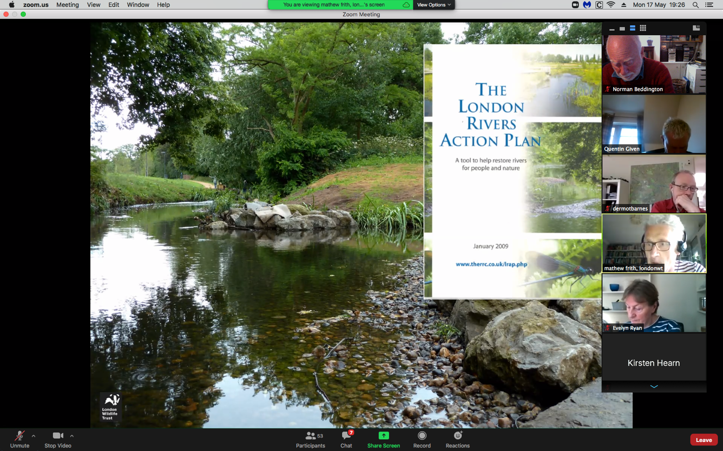

Screen shot from Annabel Foskett’s talk on the Biodiversity Action Plan

The worldwide crisis in biodiversity has been moving up the political agenda, and the pandemic has highlighted the importance of green spaces to the wellbeing of local communities. In a meeting hosted by Haringey Climate Forum on developing a Biodiversity Action Plan, Haringey discussed how nature can be helped to recover, at a London, Borough and neighbourhood level.

The London Wildlife Trust’s director of conservation Matthew Frith gave an overview of city-wide measures to promote biodiversity. These include coalitions of organisations, such as the London Biodiversity Partnership, set up in the 1990s to support wildlife in the capital, and the establishment of frameworks to assess biodiversity conservation, including the identification of Sites of Importance for Nature Conservation (SINCs): an example in the Borough is Queens Wood. Matthew also highlighted recent developments in planning for biodiversity recovery, such as the London Plan, the London Urban Forest Plan and the London Rivers Action Plan, stressing that to be effective, local communities need to be actively involved. Biodiversity action plans, he argued, must include allotments, private gardens and other spaces where wildlife can thrive, as well as parks.

Speaking for the Haringey’s Nature Conservation Officer Annabel Foskett, Alex Fraser outlined the key elements of the BAP within Haringey’s proposed Parks and Open Spaces Strategy. He stressed that biodiversity planning needs to include both medium and long-term goals; **bwhae** integrated across Council services; incorporate budgets, timelines and partnerships, and actively involve the community. If Haringey is to declare an ecological emergency, he argued, the Council needs to be able to respond with specific actions, not just worthy intentions, for this to be meaningful.

Sally Haywill, a volunteer at Lordship Recreation Ground, described how it has been transformed from an unloved and run-down space to a thriving haven for wildlife that encompasses diverse habitats: the Moselle river, grassland, woodland and scrub. An active centre for community involvement, Lordship Rec aims to become a borough-level SINC and to build on its educational and volunteering role.

The meeting concluded with a discussion of other necessary measures – such as creating wildlife corridors, protecting and planting street trees, including elements such as swift boxes in new building projects. Of course the Council is short of money and the challenges that face us are massive; but as Matthew Frith concluded, there is a great amount of new energy and action. The challenge now is to hold local landowners to account; to press the Council to make connections across departments, and to build on this enthusiasm.

*Jenny Bourne Taylor*

**WHAT YOU CAN DO IN YOUR OWN GARDEN**

There are over three million gardens in Greater London, an area of almost 40,000 hectares; this enormous expanse of green space has massive untapped potential. However research by London Wildlife Trust shows that garden greenspace has been lost in the capital at a very fast pace, driven by recent trends in garden design. Things you can do to reverse this pattern and attract more wildlife to your garden include include:

* + ***Wild up your decking:*** *add planted containers to your wooden decking. This will create attractive animal refuges, and will cool the decking area as plants retain and release moisture and create shade*
  + ***Add a green roof to your shed:*** *living roofs increase the planted area in your garden and provide extra wildlife habitat. Plant sedums, grasses and wildflowers or leave it to nature and allow wind-blown plants to colonise your roof*
  + ***Make a pond:*** *even small ponds can support a diverse wildlife and provide places for animals to bathe, drink and mate. They can be part of a local series which creates a wildlife corridor through which wildlife can travel and adapt to climate change*
  + ***Build a mini wildlife pond:*** *dig a hole deep enough to hold an old bucket or watertight container; fill any gaps with loose soil and line bottom with sand; build a pile of rocks/bricks in bottom, add pondweed and fill with rainwater*
  + ***Make a nest box:*** *use rough cut timber, some old rubber or a hinge for the roof and hang 2-5 metres above ground in a sheltered spot*
  + ***Create a butterfly garden:*** *include a sunny wall as a sunbathing spot for butterflies; plan for a long season of nectar-rich flowers; plant hops, holly and nettles to provide food for butterflies*
  + ***Grow vegetables for wildlife:*** *try planting some fruit and veg to attract wildlife: large and small white butterflies like cabbage, cauliflower and broccoli; small birds and mice go for blackberries and raspberries and hoverflies and other insects like carrot and fennel*

Some other points to think about on wilding your garden are:

* Use pesticides only when absolutely essential eg removal of tree/shrub stumps
* don’t use slug pellets; the chemicals can easily be picked up by birds so make use of beer traps or pick up snails in the early morning
* check long grass and leaf piles before disturbing as they are favourite places for hedgehogs
* cut small holes through or under boundary fences so that hedgehogs can easily cross from garden to garden, and build small shelters from them
* leave some untidy or overgrown spaces as these will encourage wildlife

*Norman Beddington*

**BIODIVERSITY IN LORDSHIP REC**

**Lordship Rec** is a very well used park in the middle of the borough on Lordship Lane covering nearly 58 acres. It is designated as Metropolitan Open Land and part of the site is a Local Site of Importance for Nature Conservation. It contains a mosaic of habitats that are managed for wildlife as well as people. The park user groups works in partnership with the Council Parks department staff to achieve the management plan (available on the park website).

**Woodland**: In the south east corner of the park there is a small area of trees planted by local residents in the mid-1980s. It has native trees and shrubs including goat willow, lime, hornbeam and oak. In addition there is a spinney and fruit and nut walk planted alongside the Broadwater Farm estate on the east side of the park.

**River**: the river Moselle runs through the park and has been taken out of its culvert to provide a water habitat. It is flanked by goat willow and water loving plants such as yellow flag iris and purple loosestrife. Along the old Moselle river bed there are decaying trunks of dead trees, which provide homes for many beetles and fungus.

Lake: once a boating lake, this area is now given over to wildlife and attracts a variety of water birds, dragonflies and bats. Bulrush and flag iris provide cover around the lake edges for frogs and toads.

**Hedges**: the park contains some 1,400 metres of hedge (mostly hawthorn, with some privet, hazel and pyracantha). The boundaries are historic hawthorn hedges, which are only cut over winter to provide nest sites and food for birds. Hedge gaps are being planted up with native shrubs – blackthorn, holly, guelder rose, spindle and hornbeam.

**Meadow**: around the mown grass in the park are areas where the grass is allowed to grow longer and the cut hay is removed so that meadow flowers can thrive to provide food for butterflies and other insects.

Park users are encouraged to use the iNaturalist app to identify and log plants and animals in the park.

*Pamela Harling*

**EXTRACTS FROM PAPER ON BIODIVERSITY ACTION PLAN by Annabel Foskett Nature Conservation Officer Haringey Council**



**

**

**

**KEY ISSUES AND OPPORTUNITIES**

* In certain wards such as Bruce Grove there is limited access to open space and recreational grounds, predominantly east / west disparity.
* The Lee Valley is a significant recreational asset which with improved access could serve a much wider section of our community
* The need for additional open space has been highlighted and made even more urgent by the significantly increased use of parks arising from the COVID-19 lockdown
* Climate change mitigation
* Urban greening factor
* Biodiversity net gain requirement for new development