High level Briefing for councillors re the plans for the Edmonton Incinerator – Cost and Ownership This is part of a series of briefing papers for decision makers covering Capacity, Emissions and Costs and Ownership with recommendations to reassess the aspects of the plan that have been subject to change. S Charles 25/07/21
Introduction
There have been significant policy and technology changes since the new incinerator proposals were originally formulated. These include: demand versus forecast capacity /recycling policies/ waste separation technology/ low carbon polices and new technologies. There is a window of opportunity to adjust to these changes to future-proof the cost effectiveness, viability and sustainability of North London waste handling.

Scene Setting
The plan was approved by the Planning Inspectorate in 2017 for the redevelopment of the Edmonton site to serve the seven North London Boroughs who jointly own NLWA and its assets. NLWA commissioned the North London Heat and Power Project (NLHPP) to deliver the transformation of the site, concluding with an Energy Recovery Facility, also known as Energy from Waste (EfW) with an incinerator capacity of 700,000 tonnes of waste, due to be contracted by early 2022 and commissioned by 2027.

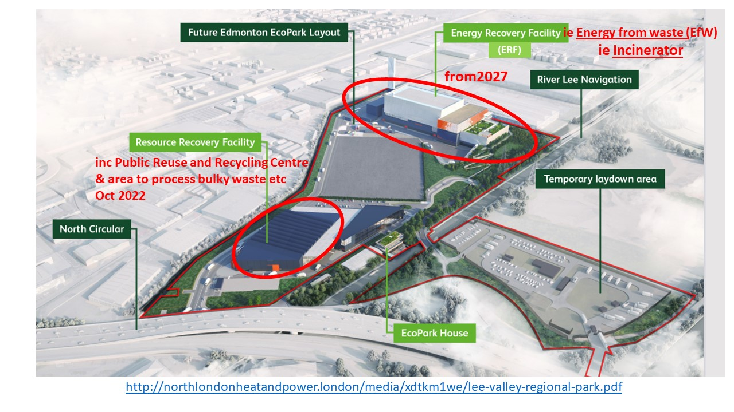
COST and OWNERSHIP
Current situation and plan
- Barnet, Camden, Enfield, Hackney, Haringey, Islington and Waltham Forest Councils own the NLWA.
- Each Council has 2 representatives on the Board.
- The North London Heat and Power Project (NLHPP) is commissioned by the NLWA to deliver the Edmonton replacement. The most recent Programme report was for June 2019.
- The NLHPP project is financed through the levy for managing the disposal of waste for each borough - about three per cent of boroughs’ total net expenditure.
- The cost to the 7 councils was £58.7m in 2018/19, planned to rise to £85.3m by 2024/25, which includes £810K for NLHPP costs and £15.8m to service capital works (prior to repayment costs ramping up) (NLWA Budget report (p13 and p32)
- London Energy Ltd runs Edmonton and is the only publicly owned body that provides incineration in the UK. It is owned by NLWA has non executives on its Board.
- The initial investment cost for the Energy Recovery Facility (incinerator) is expected to be £600m out of the full programme of £1.2bn, financed by loans.
- The Mayor of London is required to produce a municipal waste management strategy (p253) …. the waste collection and disposal authorities, businesses and the commercial waste industry will implement the waste policies in this strategy in collaboration with the Mayor.
- There is no central Government oversight of incinerator capacity versus waste volumes.
- Poverty and inequality around Edmonton is studied in the Enfield Commission Report 2020, covering high unemployment, low qualifications and low life expectancy.
- The NLWA consultation was held in September 2015 with workshop and drop in sessions to demonstrate the plan at that time (inc 7 treatment streams).
Changes since 2016
- The Deposit Return Scheme (p17) proposed by Defra states that the recent focus on the green recovery shows that the “UK economy already generates about 15 times more jobs in the reuse and repair sector than in waste disposal. (p17) Studies have shown that the introduction of a DRS could increase the number of jobs available by between 3,000 and 4,300.
- The Extended Producer Responsibility Scheme (p40) proposed by Defra for 2023 will make packaging producers and users pay for packaging disposal. As of 2024 a total transfer of 900 million pounds from companies to local authorities is expected, about 3 million per council, boosting recycling investments.
- The number and types of jobs arising from a circular economy are analysed by a Jan 2015 Green Alliance report.
- The UK would forego £1.6 billion per year in value added if it failed to boost recycling over the next 15years.) XRZerowaste’s Policy Brief (p12)
- An incineration tax could be introduced if these policies do not deliver the Government’s waste ambitions Rebecca Pow MP Jan 2021.
- The cost of adding Carbon Capture and Storage (CCS) to the project is studied in Energy from Waste Plants with Carbon Capture May 2020.
- Brexit has allowed the UK to continue to export plastics to non OECD countries
- Citizen consultation tools that enable informed, democratic consultations to take place have been further developed. Eg the UK Climate Assembly.
NLWA statements v latest information
The ‘Myth Buster statements’ include a statement that the project can’t be stopped because the planning inspectorate has approved it. This can be argued against, if the NLWA Board voted to reassess the plans prior to committing to the 2016 plans.

Risks
- That the path planned in 2016 for commission in 2027 will continue, despite the recent big changes in capacity, technology and policies. Costly refits eg for Carbon capture etc or redundant facilities would result.
- That council taxpayers of the seven Boroughs will pay significantly more for their waste services than they would with a flexible design that can match waste volume to avoid buying in feedstock and maximise sales of recyclables.
- District Heat, for residents who are required to take it, will cost them more than for lower carbon alternatives. Sutton council is accused of establishing a District Energy Network to justify the Beddington incinerator.
- Unemployed North London people will miss the chance to work in the green waste economy, where jobs will be longer term than the initial Edmonton jobs.

Recommendations to reassess
- The financial effects of adjusting the business case to take into account the current and projected changes. To include the short term costs of reassessment against the longer term costs of needing to retrospectively address them and the risk of stranded assets.
- North London residents are consulted on how they want their waste treated, with the latest information and consultation techniques.
- Research is conducted into ‘green waste jobs’ in North London, rather than elsewhere.

